Lab Test 1  
Samiul Karim  
201-15-3041  
PC-D

Answer to the question no 1

;Samiul Karim

;Ans to the question no 1

INCLUDE 'EMU8086.INC'

.MODEL SMALL

.STACK 100H

.DATA

NAM DB "Samiul Karim $"

ID DB "201-15-3041 $"

SECTION DB "PC-D $"

.CODE

MAIN PROC

MOV AX,@DATA

MOV DS, AX

MOV AH,9

LEA DX,NAM

INT 21H

PRINTN " "

LEA DX,ID

INT 21H

PRINTN " "

LEA DX,SECTION

INT 21H

PRINTN " "

PRINT "Give the name initiaL: "

MOV AH,1

INT 21H

MOV BL,AL

INT 21H

MOV CL,AL

PRINTN

PRINT "Output: "

MOV AH,2

MOV DL,BL

INT 21H

MOV DL,CL

INT 21H

MOV AH,4CH

INT 21H

MAIN ENDP

END MAIN

Screenshot: 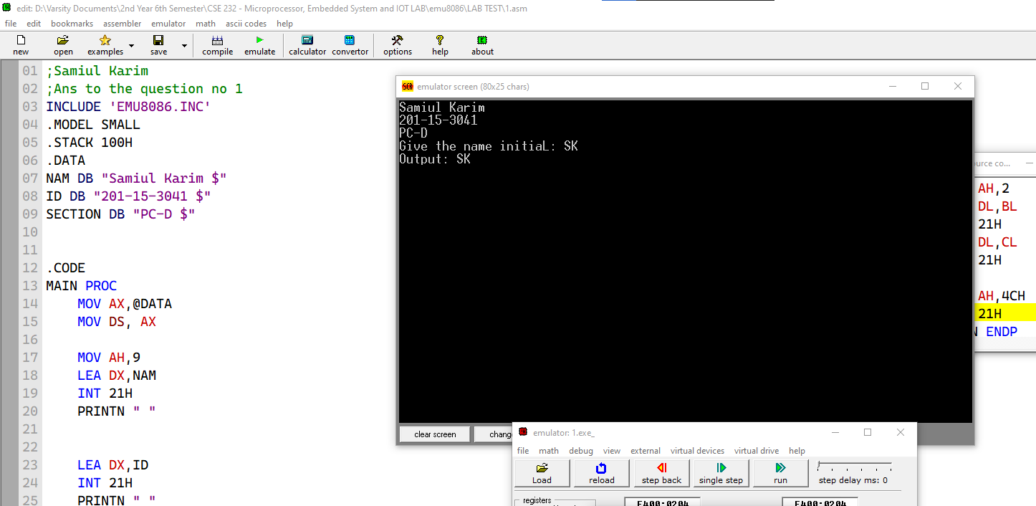

Answer to the question no 2

INCLUDE 'EMU8086.INC'

.MODEL SMALL

.STACK 100H

.DATA

.CODE

MAIN PROC

PRINT "Input: "

MOV AH,1

INT 21H

MOV BL,AL

PRINTN " "

PRINT "Output: "

MOV AH,2

MOV DL,BL

INT 21H

MOV AH,4CH

INT 21H

MAIN ENDP

END MAIN

Screenshot:

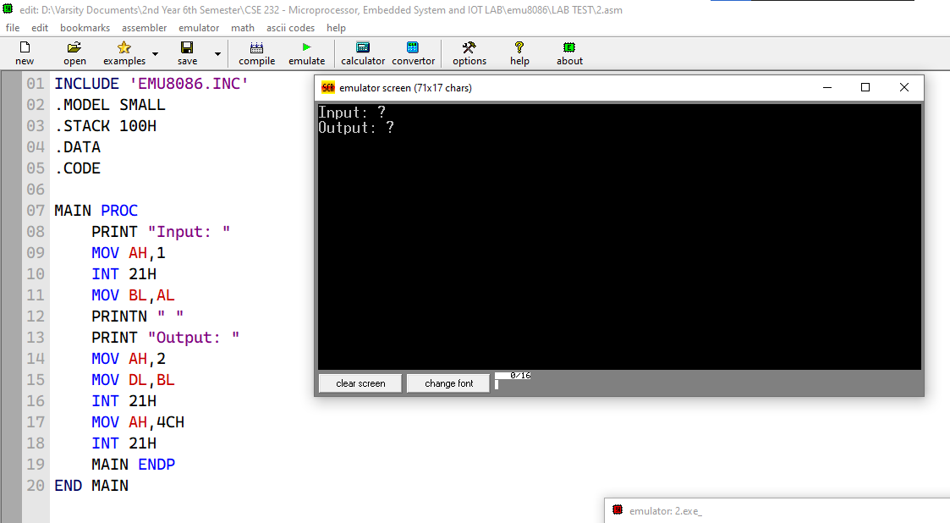

Answer to the question no 3

1. Summation

;Samiul Karim

;Addition

INCLUDE 'EMU8086.INC'

.MODEL SMALL

.STACK 100H

.DATA

S DB ?

K DB ?

P DB ?

.CODE

MAIN PROC

MOV AX,@DATA

MOV DS,AX

PRINT "Enter the first digit: "

MOV AH,1

INT 21H

MOV S,AL

PRINTN

PRINT "Enter the second digit: "

MOV AH,1

INT 21H

MOV K,AL

PRINTN

PRINT "Enter the third digit: "

MOV AH,1

INT 21H

MOV P,AL

PRINTN

MOV CL,S

MOV BL,K

MOV BH,P

PRINT "The summation of three numbers: "

ADD CL,BL

SUB CL,30H

ADD CL,BH

SUB CL,30H

MOV AH,2

MOV DL,CL

INT 21H

MOV AH, 4CH

INT 21H

MAIN ENDP

END MAIN

Screenshot:

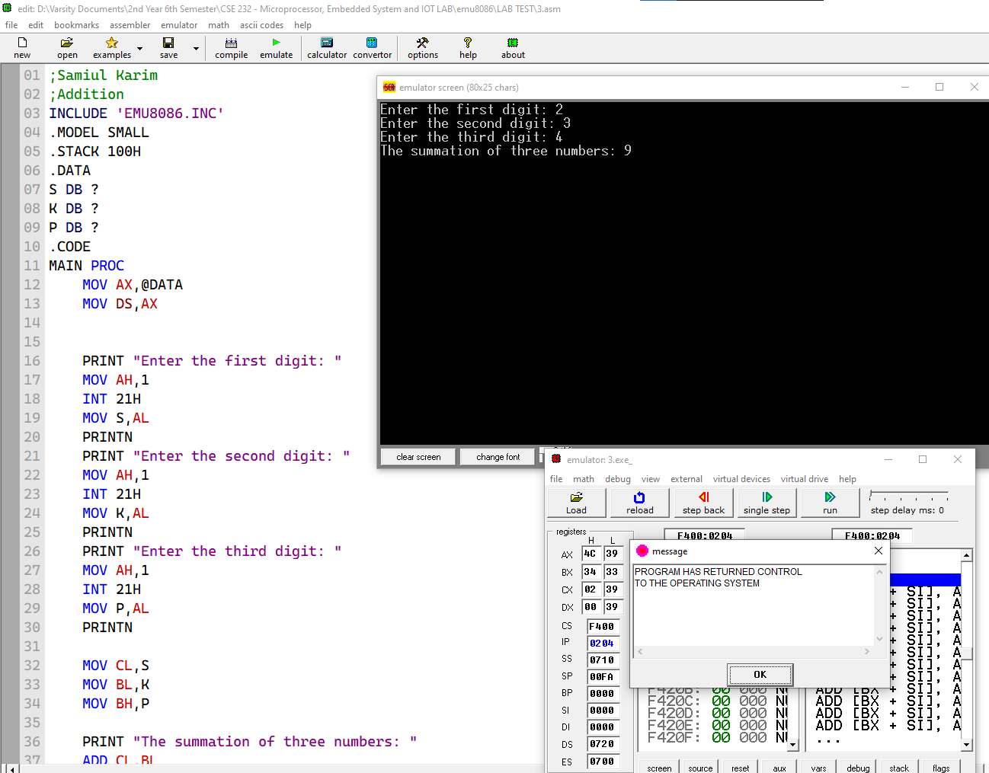

1. Subtraction

;Samiul Karim

;Addition

INCLUDE 'EMU8086.INC'

.MODEL SMALL

.STACK 100H

.DATA

S DB ?

K DB ?

P DB ?

.CODE

MAIN PROC

MOV AX,@DATA

MOV DS,AX

PRINT "Enter the first digit: "

MOV AH,1

INT 21H

MOV S,AL

PRINTN

PRINT "Enter the second digit: "

MOV AH,1

INT 21H

MOV K,AL

PRINTN

PRINT "Enter the third digit: "

MOV AH,1

INT 21H

MOV P,AL

PRINTN

MOV CL,S

MOV BL,K

MOV BH,P

PRINT "The subtraction of three numbers: "

SUB CL,BL

ADD CL,30H

SUB CL,BH

ADD CL,30H

MOV AH,2

MOV DL,CL

INT 21H

MOV AH, 4CH

INT 21H

MAIN ENDP

END MAIN

Screenshot:

